AQ-1 Prototype Implementation & Deployment
  - Technical Artefact 2

1. Prototype Scope & Implementation Overview

1.1 Purpose and implementation context
Our AQ-1 project shows how an aquaculture monitoring system can collect sensor readings, send them through MQTT and check whether the data can be trusted. We built a small university prototype rather than installing a system on a real fish farm.
We use an ESP32-C3 with a DS18B20 temperature sensor, together with simulated dissolved oxygen (DO-001) and pH (PH-001) sensors in GNS3. The main demo focuses on temperature and dissolved oxygen. A Python gateway checks message signatures, while Node-RED and SQLite support monitoring.

1.2 Implemented demonstration functions
In the demonstration, the sensors send readings, the gateway checks their HMAC signatures and the monitoring interface shows trusted data. The gateway also checks message sequence numbers and identifies missing valid readings. Invalid messages should not update trusted values. SAFE/HOLD is only a warning shown in the software; it does not control real pumps or aerators.
We planned to show normal data, a tampered message, a replay and a sensor outage. We also considered testing from another team computer, with the local GNS3 attacker as a backup. We have not treated the remote test as completed without evidence.

1.3 Deployment boundary
We ran the virtual part in GNS3 on VMware, using Alpine-based Docker nodes for the sensors, gateway and attacker. The project package also includes Node-RED and SQLite files. The final demonstration uses the public HiveMQ broker at broker.hivemq.com:1883; we used Mosquitto during earlier development.

1.4 Demonstration scope and limitations
Included in the prototype / showcase | Outside the demonstrated farm deployment
Physical temperature, simulated DO and optional simulated pH sources | Six permanently installed stations and 18 live farm measurements
MQTT, signed JSON, HMAC verification and sequence replay checks | Fully commissioned industrial fieldbus and production-grade key management
Node-RED / SQLite monitoring and software SAFE/HOLD alerts | Actuation of real aerators, pumps or feeders
Isolated attacker role and optional cross-team attack path | Public-network attack testing or a production security assessment
VM-based networking across the demonstration environment | Full three-pond fibre, power and enclosure installation

1.5 Evidence and traceability
The project repository and the figure locations provide traceability for the described implementation. Figures distinguish architecture, message handling and dashboard behaviour.
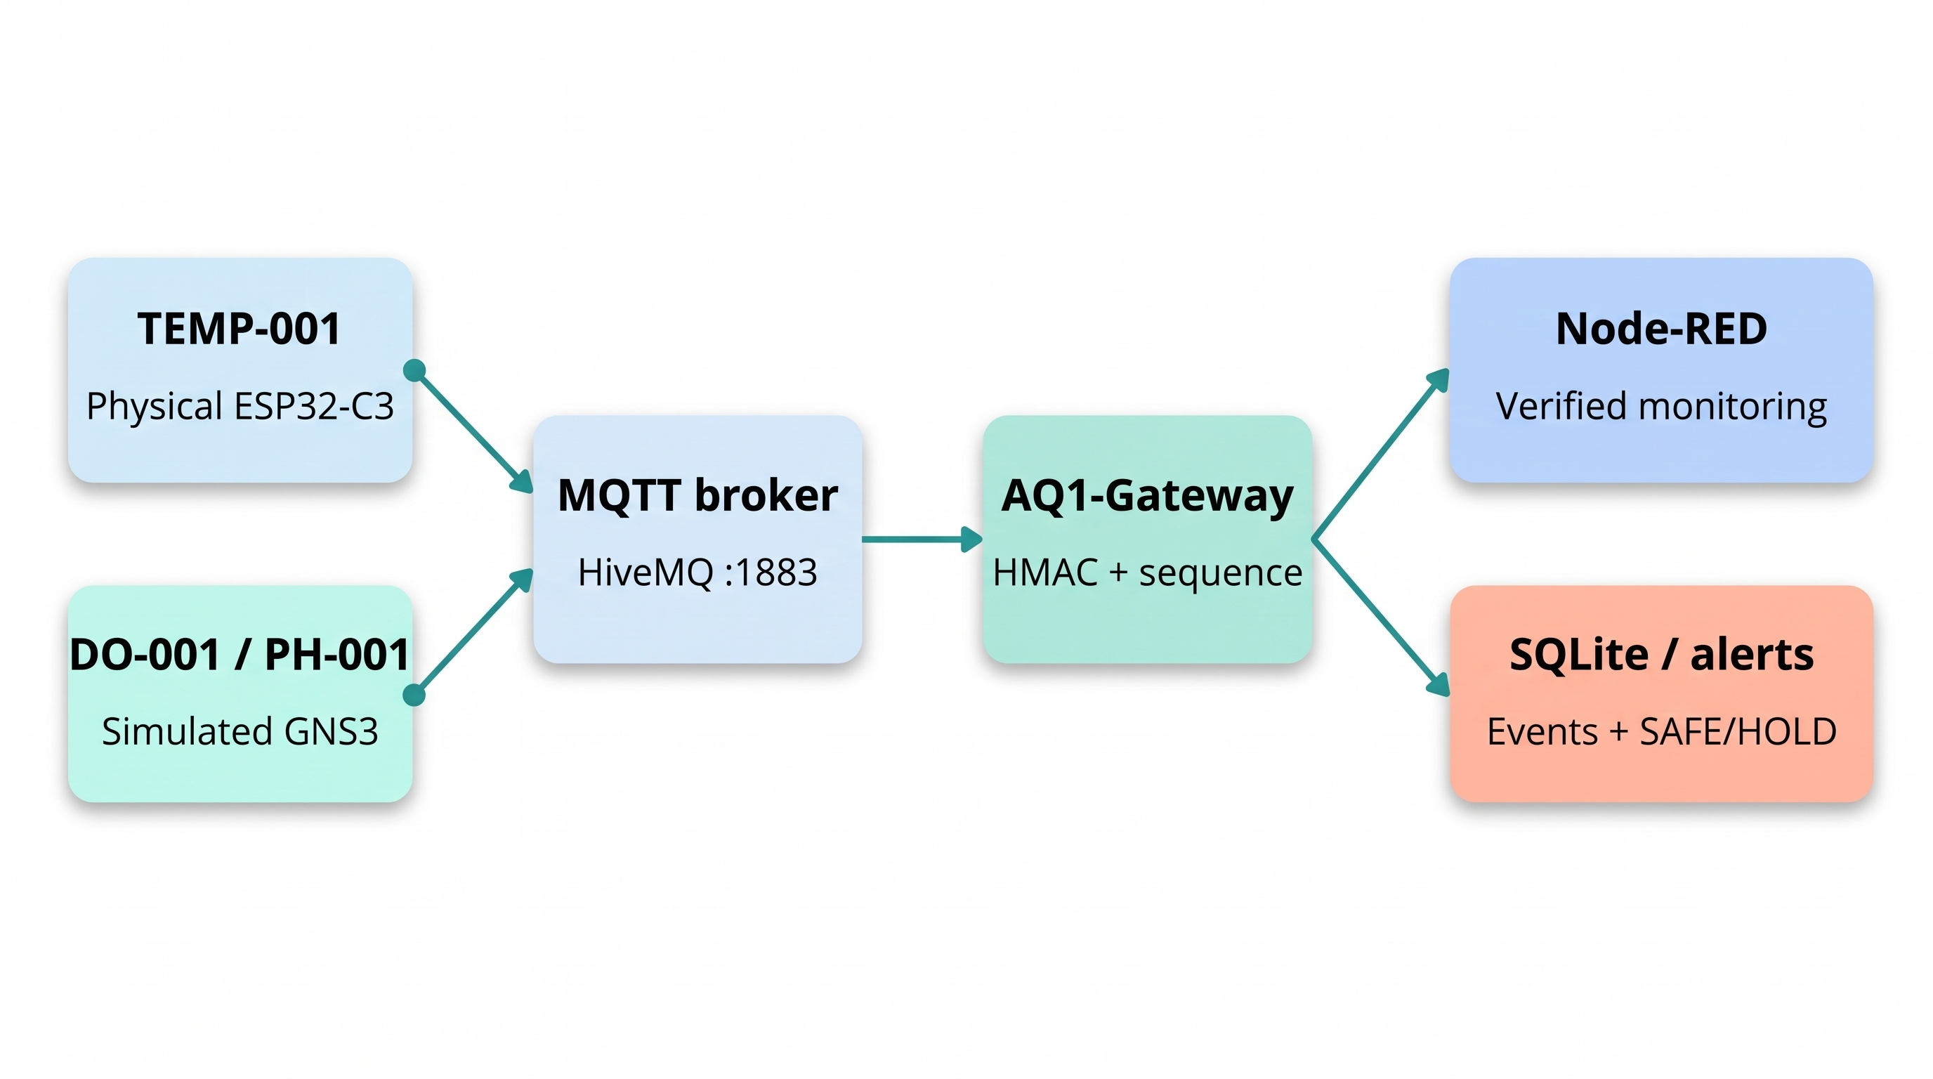
Figure 1: Showcase data paths for physical TEMP-001 and simulated DO-001/PH-001 through MQTT verification and monitoring.
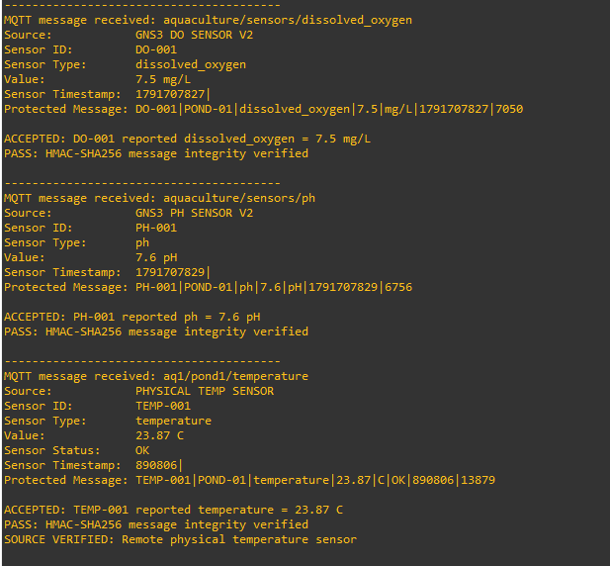
Figure 2: Gateway console recording acceptance of authenticated sensor messages.

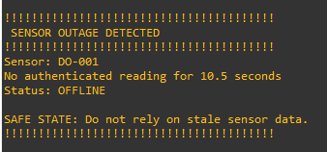
Figure 3: Gateway outage warning and software safe-state indication.
Repository: https://github.com/nininehaa/aq1-secure-aquaculture-iot.git
Figures 1–3 identify the deployment topology and examples of genuine gateway acceptance and outage reporting. Screenshots are captured from the project environment; where a figure demonstrates only one security condition, its caption is restricted to that observation.

2. Hardware, Software & Development Environment

2.1 Implementation platform
We used Windows laptops with VMware and GNS3. GNS3 runs the separate Alpine Docker nodes for the sensors, gateway and attacker. Node-RED and the database come in a separate package. This setup lets us repeat the demo without real farm equipment.

2.2 Prototype equipment and computing roles
The real hardware is an ESP32-C3 and waterproof DS18B20 temperature sensor. DO-001 and PH-001 are Python sensor simulations in GNS3. The attacker node is only used for our authorised security demonstration, and Node-RED displays readings and alerts.
Component / role | Implementation choice | Purpose / evidence to record
Host computers | Team Windows computers with VMware Workstation Pro | Run and interconnect demonstration VMs; record host specifications and network interfaces
Temperature source | ESP32-C3 with waterproof DS18B20; GPIO4 one-wire interface; Arduino firmware and photograph | Provide real sensor input; add wiring, firmware and photograph
DO source | Python DO-001 publisher (GNS3 Alpine Docker node); real hardware not used | Generate identified DO readings for MQTT publication
pH source | Python PH-001 publisher (GNS3 Alpine Docker node); additional simulated stream | Generate identified pH readings for MQTT publication
Verification gateway | Python gateway service in Alpine Linux VM | Verify signed payloads and separate accepted from rejected messages
Attacker | Isolated Alpine Linux VM / second team computer | Generate authorised malicious or altered traffic for the showcase
Operator dashboard | Node-RED service | Display trusted readings, status and alerts

2.3 Software stack and configuration ownership
The firmware and Python scripts implement sensor sampling or simulation, JSON preparation, HMAC-SHA256 signing and gateway verification. Paho-MQTT provides Python MQTT connectivity. The final transferred showcase configuration specifies the public HiveMQ broker (broker.hivemq.com, TCP port 1883); a local Eclipse Mosquitto broker was used during development (Eclipse Foundation n.d.; OASIS 2019). Node-RED and SQLite provide operator monitoring and event storage. Authentication secrets must remain outside published screenshots and repository commits. The broker does not itself verify application-layer HMACs.
Software | Function | Version / configuration evidence
VMware Workstation Pro | Virtual machines and virtual network adapters | Host virtualisation for the GNS3 VM; actual host/version varies
Alpine Linux | Lightweight guest operating system | Alpine Docker-node image declared in the exported GNS3 project
Python + paho-mqtt | Sensor publishers and gateway subscriber | Python gateway.py; DO/PH scripts and Paho-MQTT; runtime version not recorded
Eclipse Mosquitto | MQTT message broker | Local development broker only; final showcase uses HiveMQ public MQTT, TCP 1883
Node-RED | Monitoring and operator dashboard | Exported flows.json, package.json and aq1_team2.db supplied for Node-RED
Git / GitHub | Shared source and configuration history | Repository: github.com/nininehaa/aq1-secure-aquaculture-iot; final commit not supplied

2.4 Development and deployment practices
Each virtual machine has a defined demonstration role, separating publisher, verification, monitoring and attacker functions. This separation helps isolate faults and makes the workflow reproducible. Broker credentials, HMAC secrets and any device access information should be stored securely and redacted from screenshots. The project repository is the reference for source files, while the prototype deployment settings are documented in the reproduction guide.
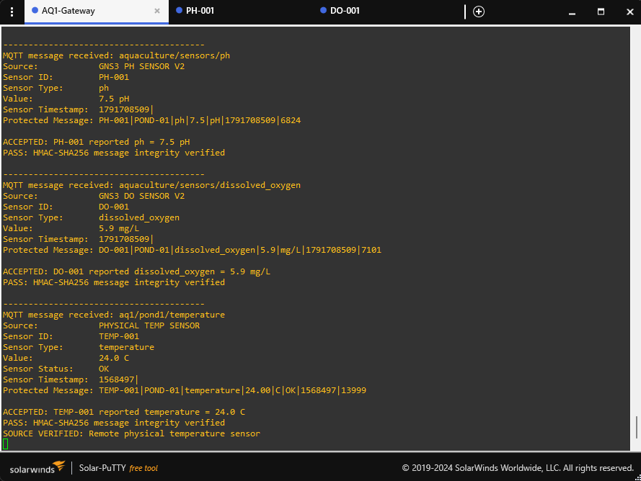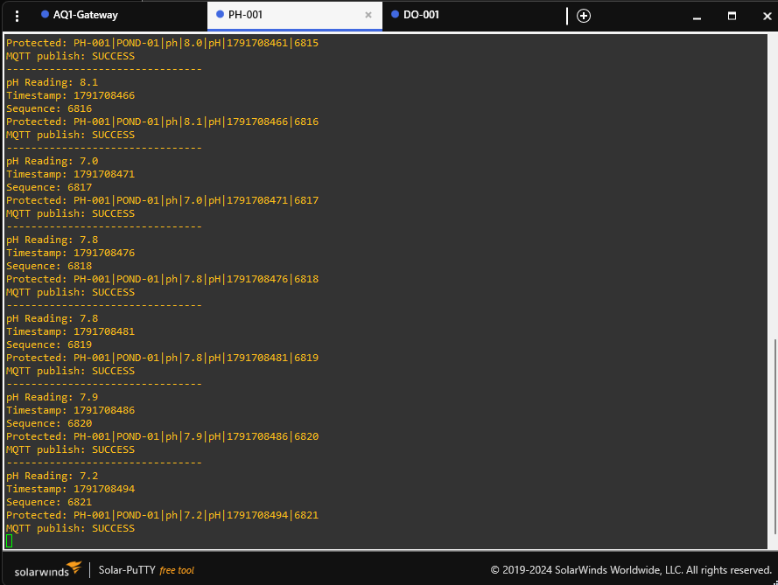

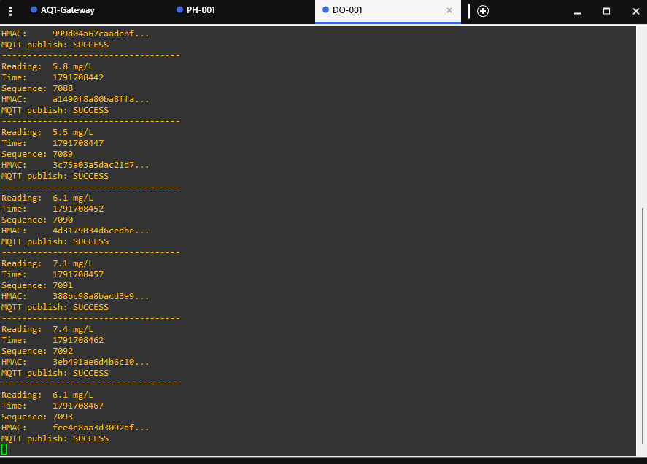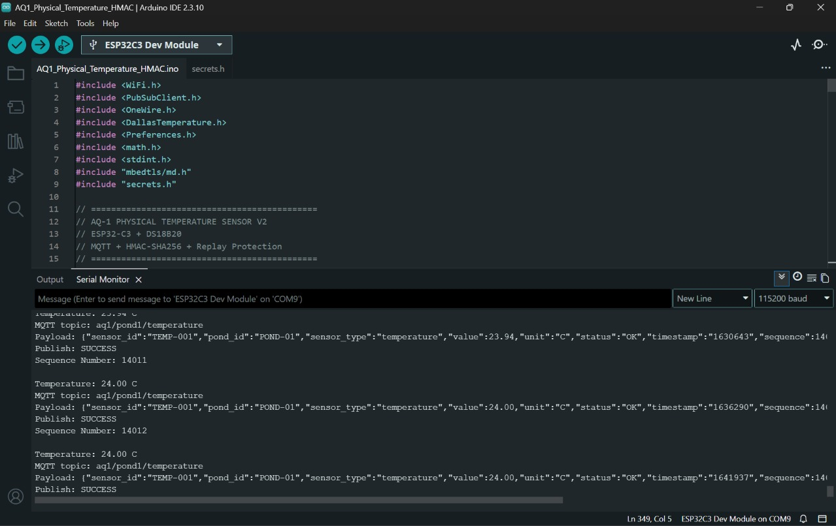

Figure 4: Screenshots of virtual sensor services and physical temperature firmware running in the development environment.

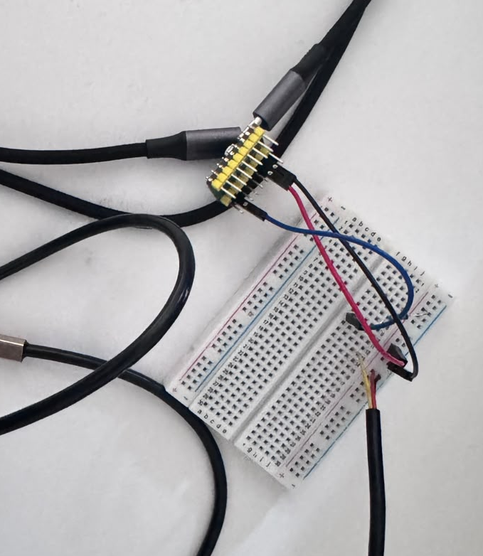
Figure 5: Physical temperature sensor, interface and wiring used in the prototype.

3. Virtual Network & System Deployment

3.1 Network design and communication paths
Our simulated sensors, gateway and attacker are separated into GNS3 roles. Messages travel through the public HiveMQ MQTT broker. The gateway receives them, checks their signatures and sends trusted results and events to monitoring. The ESP32 publishes temperature readings over Wi-Fi, outside GNS3.

3.2 Virtual machine topology
The exported GNS3 project contains NAT1, Switch1, Cloud1 and Alpine Docker nodes named DO-001, PH-001, AQ1-Gateway, AQ1-Monitor and Attacker1. A separate ESP32-C3 publishes physical temperature readings outside the simulated sensor nodes. Virtual interfaces and IP addresses depend on the machine used to run the project, so the table lists reproducible node roles rather than asserting temporary addresses.
Node / service | Network role | Final host / IP / adapter
DO-001 | MQTT DO publisher | GNS3 DO-001 node; aq1/team2/sensors/dissolved_oxygen
PH-001 | MQTT pH publisher | GNS3 PH-001 node; aq1/team2/sensors/ph
Temperature source | Physical sensor interface / publisher | ESP32-C3 over Wi-Fi; aq1/pond1/temperature
Gateway | MQTT subscriber and HMAC verifier | GNS3 AQ1-Gateway Docker node; MQTT subscriber / verifier
MQTT broker | Message transport endpoint | broker.hivemq.com, TCP 1883 (public test broker; unencrypted)
Dashboard / Node-RED | Monitoring web interface | Local Node-RED runtime; host/port depends on installation
Attacker | Isolated test traffic source | GNS3 Attacker1 Docker node on the virtual switch
Second team computer | Optional cross-team attack route | Optional external demo route; successful live exercise not evidenced

3.3 Broker access and routing
The final transferred gateway and sensor scripts use broker.hivemq.com:1883. Physical temperature is published to aq1/pond1/temperature; the simulated DO and pH streams use aq1/team2/sensors/dissolved_oxygen and aq1/team2/sensors/ph. The gateway publishes accepted readings and events on separate aq1/team2/gateway and aq1/team2/events paths. Topic prefixes organise messages but do not provide broker-enforced isolation. The public MQTT connection is unencrypted; TLS, access-control lists and broker authentication remain production enhancements rather than implemented showcase controls.

3.4 Cross-team connectivity and attack path
The optional cross-location exercise would use a coordinated attacker client to publish a forged message to an agreed simulated sensor test topic, where the receiving gateway should reject it. Its successful execution is not established by the supplied evidence. The local Attacker1 node and captured replay messages provide a reproducible fallback. Tests must not target the shared physical temperature topic.

3.5 Connectivity checks and troubleshooting evidence
Connectivity is assessed by observing a valid publisher message, broker delivery, an accepted gateway verdict and corresponding Node-RED display. Separate evidence should show rejected attack traffic and outage handling. A running process alone does not prove end-to-end delivery: MQTT subscription paths, GNS3 VM links, network rules and dashboard service availability must each be checked. Figures 7 and 10–14 provide examples of the captured gateway and dashboard outputs.
Check | Expected observation | Evidence
VM addressing | Each VM has the intended subnet and route | Figure 6: GNS3 topology (IP values are not documented)
Broker reachability | Publisher and subscriber can reach broker | Figure 9: ESP32 MQTT publishing; Figures 8 and 10: software messages and verification
Valid data path | Gateway accepts correctly signed reading | Figures 2 and 10: authenticated gateway acceptance
Dashboard reachability | Dashboard loads from designated operator computer | Figures 7 and 13: monitoring interface in project environment
Attack path | Invalid payload reaches verification and is rejected | Figure 11: replay rejection recorded; wrong-HMAC test requires separate evidence
Fallback | Local attacker produces equivalent demonstration | Attacker1 scripts present in export; fallback live run not evidenced

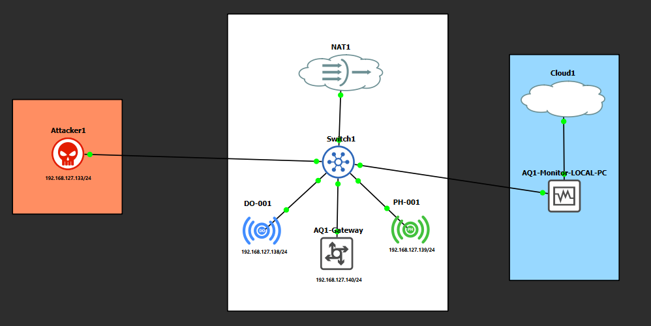
Figure 6: Exported GNS3 topology and logical network links (not a verified inventory of all host IP addresses).
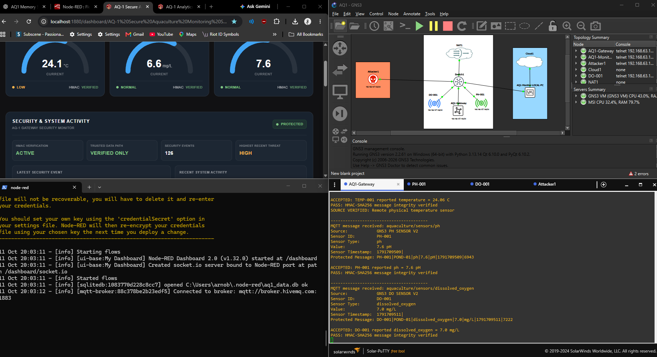
Figure 7: Captured dashboard, topology and gateway-console evidence from the prototype environment.

3.6 Deployment boundary and reproducibility
The network is a controlled prototype, not the private fibre or industrial field network proposed for the full aquaculture farm. Technical Artefact 7 presents the reproduction procedure, including VM roles, broker setup, service launch order and validation commands. Detailed security test results belong in Artefact 4 and system validation measurements in Artefact 5.

4. Sensor Simulation & Data Transmission

4.1 Sensor sources and implementation approach
We used one physical temperature sensor and simulated dissolved oxygen and pH sources. This gives us real sensor input while keeping the rest of the project practical for a university lab. The simulated readings are for checking data flow and security, not for proving real pond conditions.

4.2 Sensor publisher workflow
Each publisher associates a measurement with a sensor identity, pond, type, unit, timestamp and monotonically increasing sequence number before generating the HMAC and sending JSON over MQTT. The GNS3 gateway subscribes to the relevant topics and independently checks authenticity and freshness. The DO and pH publishers are separate from the physical TEMP-001 publisher.
Source | Implementation | Data path / confirmation
Dissolved oxygen | Python sensor publisher (DO-001) | aq1/team2/sensors/dissolved_oxygen; five-second interval in exported script
pH | Python sensor publisher (PH-001) | aq1/team2/sensors/ph; simulated node present (interval not established here)
Temperature | Physical sensor and publisher/interface | ESP32-C3 + DS18B20; aq1/pond1/temperature; Figure 9 records a publisher reading

4.3 Message format and signing
The exported source uses JSON and HMAC-SHA256, with strict canonical formatting shared by the publisher and gateway. Physical TEMP-001 signs eight fields: sensor_id|pond_id|sensor_type|value|unit|status|timestamp|sequence. DO-001 and PH-001 sign seven fields without status: sensor_id|pond_id|sensor_type|value|unit|timestamp|sequence. A mismatch in field order or numeric formatting causes verification to fail. The gateway checks the signed data first and then applies sequence-based replay protection. HMAC does not encrypt readings or prevent replay without those additional checks.
Example JSON message structure:
{"sensor_id":"DO-001","pond_id":"POND-01","sensor_type":"dissolved_oxygen","value":6.7,"unit":"mg/L","timestamp":1791700431,"sequence":7015,"hmac":"<redacted>"}
The HMAC tag is intentionally redacted. This example illustrates the signed-message field structure and is not presented as a captured MQTT packet.

4.4 MQTT publishing and data handling
The public HiveMQ broker carries messages but does not determine whether they are authentic. A sensor publishes to its topic and the Python gateway receives, parses and verifies the signed payload before accepted readings can update trusted state. Publisher scripts store increasing sequence counters, and the gateway maintains replay state in replay_state.json. The transferred gateway checks DO/pH message-age limits and sequence numbers; TEMP-001 uses sequence checking but its millis-based timestamp is not comparable to Unix time. MQTT at port 1883 is not protected by TLS in this demonstration.

4.5 Fault scenarios and evidence
The sensor demonstration covers normal publication, deliberately modified readings and interruption of expected data. The outage demonstration depends on the last accepted reading for each sensor, not simply the most recent received MQTT packet. The figure locations connect publisher output, gateway decisions and dashboard state.
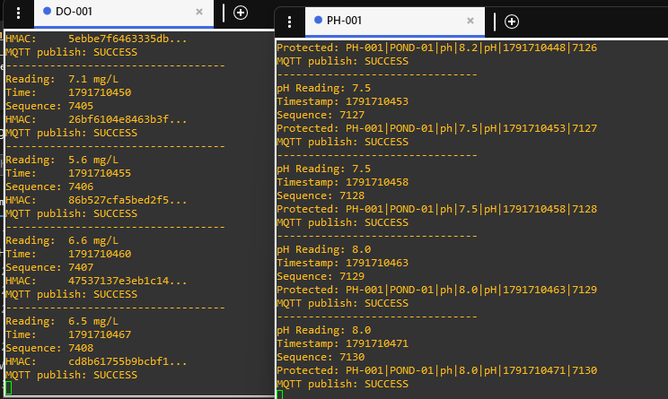
Figure 8: DO and pH sensor publishers transmitting JSON readings to MQTT.
Figure 9: Physical temperature sensor, wiring and corresponding MQTT reading.

5. Gateway Implementation & Security Integration

5.1 Verification gateway responsibilities
The Python gateway decides whether incoming readings can be trusted. It checks the message fields and HMAC, then applies sequence checks before accepting a value. It keeps the last valid reading so the monitoring system can identify missing or invalid updates.

5.2 HMAC-SHA256 integration
The sensor publishers and gateway hold corresponding HMAC signing material. The sender produces a tag over a canonical pipe-separated message and the gateway recomputes it independently. Temperature readings use two decimal places in the signed value, while the simulated DO/pH streams use one decimal place. Logs show accepted readings and rejected replay attempts; an HMAC key is not included in this artefact. This is shared-secret authenticity and integrity, not encryption or hardware-bound proof of identity.
Processing step | Expected gateway behaviour | Evidence
Receive and parse | Read MQTT payload and validate required JSON fields | gateway.py in exported GNS3 project; Figure 10 console
Identify source | Associate sensor ID and type with configured stream | Configured TEMP-001, DO-001, PH-001 identities and topics in gateway.py
Verify integrity | Recompute HMAC and compare with received signature | Figures 2 and 10 for acceptance; Figure 11 for sequence-replay rejection
Update monitoring | Forward accepted readings; do not refresh last-valid time on rejection | Verified-message event path in Node-RED flows.json; Figure 13 dashboard
Handle interruption | Raise stale/outage condition and demonstrate SAFE/HOLD indication | Figures 3, 12 and 14: outage / software safe-state display

5.3 Rejection handling and attacker demonstration
The exported attacker node includes a forged-message script and capture/replay scripts. The gateway rejects invalidly signed messages, unrecognised sensor/topic combinations and duplicate/older sequence numbers. Figure 11 specifically documents a rejected DO replay attempt; it must not be mislabelled as proof of an HMAC mismatch. The exact attack exercises and observations are addressed in Technical Artefact 4.

5.4 Monitoring, outage and SAFE/HOLD interface
Only verified measurements should update the sensor’s last-valid-reading time. When a sensor stops delivering valid information, monitoring can mark it unavailable and raise an alert. The showcase uses a SAFE/HOLD indication to illustrate a protective response when dependable data are missing. This is a software demonstration and does not command physical aerators, pumps or feeders. The prototype demonstrates the transition from current to unavailable sensor information without asserting an unmeasured recovery time.

5.5 Security limitations and deployment safeguards
HMAC checks integrity and shared-secret authenticity but cannot encrypt payloads or prevent network disruption. The exported gateway adds sequence-based replay detection with state persistence; simulated DO/pH packets also undergo timestamp freshness checking, while the ESP32 millis timestamp is not Unix time. MQTT broker authentication, TLS, topic ACLs and production-grade device-key management are not established in the transferred showcase. Secrets and credentials must not appear in screenshots or public commits.

5.6 Integration evidence
Figures 10–12 show the gateway accepting authenticated sensor messages, rejecting a DO replay and reporting loss of authenticated data. These captures support the indicated gateway behaviour only; they do not prove a real pump or aerator was controlled. The complete test procedure and measured validation remain the subject of Technical Artefacts 4 and 5.
Figure 10: Gateway output recording successful verification of authenticated sensor messages.
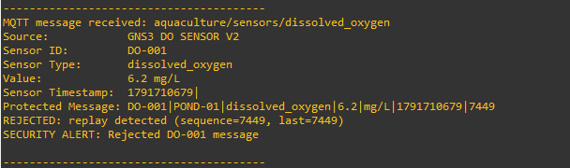
Figure 11: Rejected replay of a previously accepted DO-001 message.
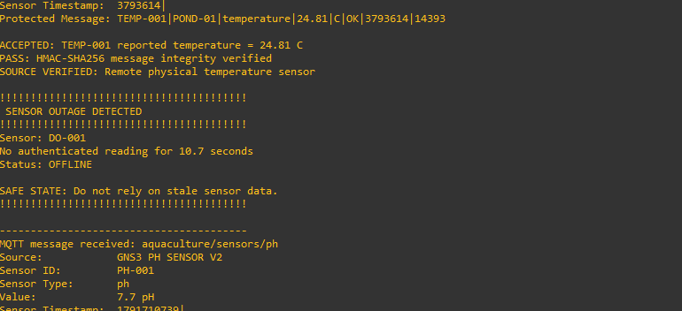
Figure 12: Gateway log showing loss of authenticated sensor data and software safe-state warning.

Project-specific implementation is documented in the team repository (AQ-1 Project Team 2026). MQTT, Python and Node-RED behaviour is supported by the references at the end of this artefact.

6. Monitoring Dashboard & System Integration

6.1 Dashboard purpose and implementation
The Node-RED dashboard is the operator view of our prototype. It is intended to show accepted sensor readings and alerts rather than treating every MQTT message as correct. SQLite is used to store monitoring data and events.

6.2 Trusted reading and status flow
The implemented logical path is sensor publisher → HiveMQ MQTT broker → Python GNS3 verification gateway → verified-event topics → Node-RED dashboard and SQLite storage. Failed signatures, invalid sequences and stale messages are excluded from the accepted-reading path. Sensor availability is monitored separately using the timestamp of the last verified packet, preventing invalid traffic from resetting a source to healthy. Figure 13 illustrates the dashboard view and Figure 14 an offline/safe-state display.
Displayed item | Purpose | Evidence / configuration to insert
Latest accepted physical temperature and simulated DO/pH | Provide current water-quality visibility | Figure 13: actual dashboard; published source data reaches gateway before monitoring
Sensor identity and last-valid time | Distinguish active from stale sources | Figures 12 and 14: offline indicator; monitoring logic in gateway.py
Invalid-message event | Show rejection without accepting altered data | Figure 11: replay rejection; gateway publishes security-event topics
Outage and SAFE/HOLD state | Illustrate protective behaviour during loss of trusted data | Figure 12: outage gateway log and Figure 14 dashboard offline display

6.3 Outage indication and SAFE/HOLD representation
The demonstration includes a sensor interruption followed by an availability alert and a SAFE/HOLD indication. The monitoring logic should base the outage timer on the most recent accepted reading; a rejected attacker message must not reset that timer. SAFE/HOLD in this prototype is a displayed software state and does not switch physical aerators, pumps or feeders. The SAFE/HOLD indication illustrates the operational response to loss of dependable measurements, without controlling physical equipment.

6.4 End-to-end integration and operator access
End-to-end readiness requires a publisher to send a signed reading, the broker to deliver it, the gateway to accept it and the dashboard to show the corresponding trusted value. A second run with altered traffic should demonstrate rejection without a false dashboard update. The operator interface is served through Node-RED, with dashboard access separated from the sensor publishing roles. The optional second-computer attack route follows the showcase plan, with the local attacker VM retained as a fallback.
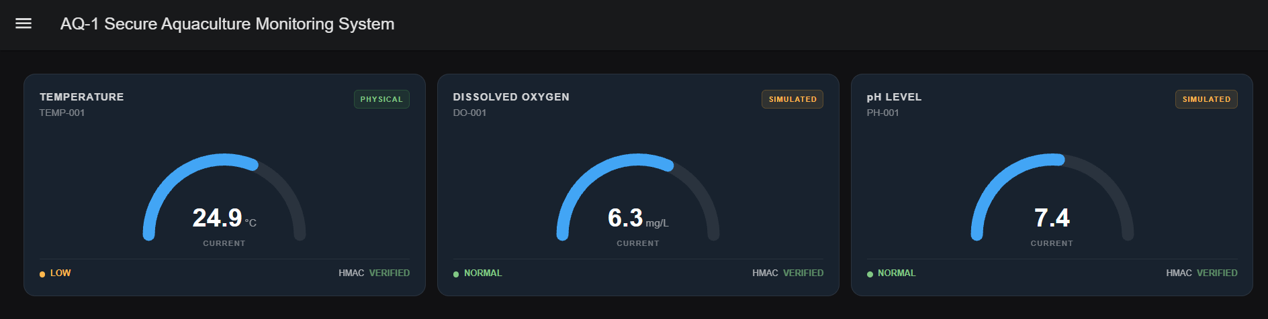Figure 13: Node-RED dashboard showing accepted sensor readings and source status.
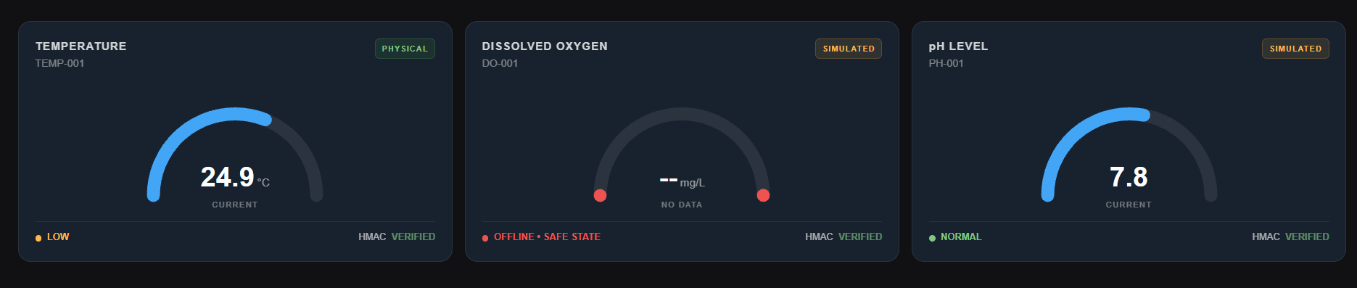Figure 14: Dashboard alert and SAFE/HOLD indication after a sensor outage.
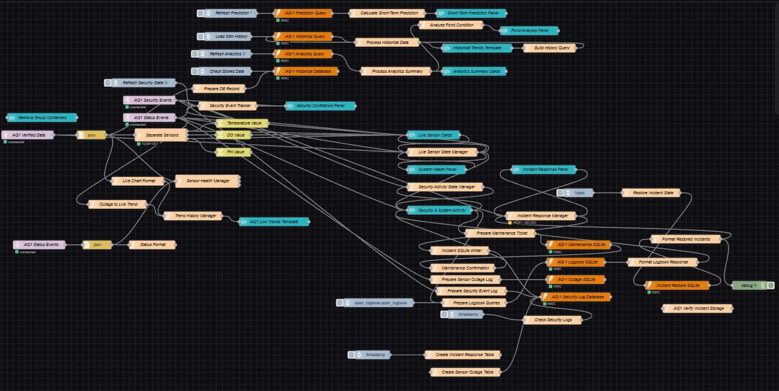Figure 15: Node-RED flow.

7. Deployment Status, Limitations & Evidence

7.1 Implementation summary
Our prototype brings together an ESP32 temperature sensor, simulated DO/pH sensors, MQTT, a Python verification gateway and Node-RED monitoring. It shows how accepted data can be kept separate from tampered or missing readings. This is a laboratory demonstration, not a finished farm control installation.

7.2 Deployment and evidence register
Component / test | Expected evidence | Status for final review
Host and VM inventory | VM settings, OS versions, host assignment, adapter modes | GNS3 topology available (Figure 16); host VM versions/IPs not captured
Physical temperature source | Sensor photo, model, wiring and sample message | Physical sensor and serial publication available (Figures 5 and 9)
DO/PH publisher simulation | Publisher terminal output, topics and JSON payloads | DO and pH publishers in GNS3 export; simulated publisher evidence Figure 8
MQTT and gateway | Broker configuration and valid-message ACCEPTED log | HiveMQ configured in source; authenticated gateway logs Figures 2 and 10
Integrity rejection | Altered-message publication and REJECTED log | Replay rejection is recorded in Figure 11; invalid HMAC needs distinct log
Monitoring dashboard | Node-RED flow export and trusted-reading display | Exported Node-RED flow / SQLite and dashboard Figure 13
Outage / software SAFE-HOLD | Last-valid timestamp, alert and software state evidence | Outage and software safe-state logs and display Figures 3, 12 and 14
Cross-team or local attack | Network path and chosen live demonstration output | Attacker scripts available; cross-city success not evidenced
Repository snapshot | Final Git commit/tag and configuration file list | Repository URL listed; final commit/version must be verified online

7.3 Known limitations and evidence boundaries
This university prototype is not a fully deployed industrial farm network with six permanent monitoring stations. The transferred PH-001 and DO-001 publishers are simulated and do not represent physical probes; temperature is provided by an ESP32-C3 and waterproof DS18B20. There is no evidenced control of pumps, feeders or aerators. HMAC is not encryption, and the public broker at port 1883 lacks TLS and configured topic ACLs. Sequence-based replay checking is included in the gateway in the provided project, but long-term resilience, key compromise and production deployment have not been evaluated.

7.4 Handover and reproducibility
The handover structure identifies VM roles, MQTT broker, publisher and gateway services, Node-RED interface and the normal, rejected and outage demonstration sequence. Technical Artefact 7 provides the reproduction workflow. Security test procedures and measured results are retained for Artefacts 4 and 5 to avoid repeating unverified claims in this implementation record.

7.5 Final evidence checklist and sign-off
The evidence register groups architecture, publishing, verification, dashboard and outage illustrations. Credentials and HMAC secrets are excluded from this document. The screenshots and diagrams have designated figure locations throughout the artefact.
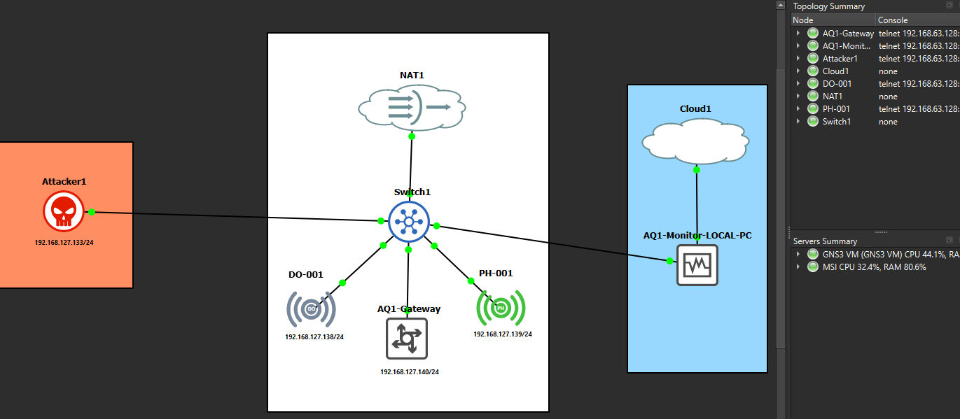
Figure 16: Final deployment inventory and verified VM/network configuration.

7.6 Source and reference notes
Project source repository: https://github.com/nininehaa/aq1-secure-aquaculture-iot.git (AQ-1 Project Team 2026). Software and protocol references appear below.

References
AQ-1 Project Team 2026, AQ-1 Secure Aquaculture IoT, GitHub repository, viewed 11 October 2026, <https://github.com/nininehaa/aq1-secure-aquaculture-iot>.
Alpine Linux n.d., Alpine Linux documentation, viewed 11 October 2026, <https://wiki.alpinelinux.org/>.
Eclipse Foundation n.d., Eclipse Mosquitto documentation, viewed 11 October 2026, <https://mosquitto.org/documentation/>.
OASIS 2019, MQTT version 5.0, OASIS Standard, viewed 11 October 2026, <https://docs.oasis-open.org/mqtt/mqtt/v5.0/mqtt-v5.0.html>.
OpenJS Foundation n.d., Node-RED documentation, viewed 11 October 2026, <https://nodered.org/docs/>.
Python Software Foundation n.d., hmac — Keyed-hashing for message authentication, Python documentation, viewed 11 October 2026, <https://docs.python.org/3/library/hmac.html>.
VMware n.d., VMware Workstation Pro documentation, Broadcom, viewed 11 October 2026, <https://techdocs.broadcom.com/>.

